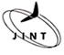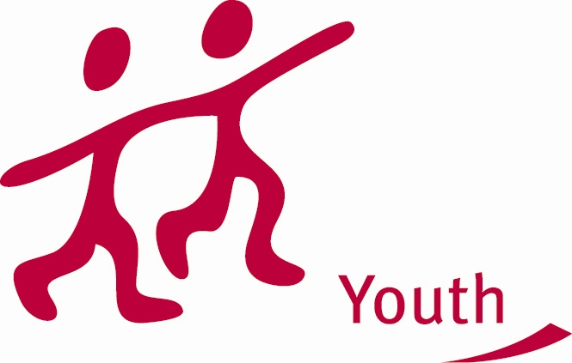

YOUTH IN ACTION
PARTNER REQUEST FORM
TRAINING AND NETWORK PROJECTS

Please complete in English!

ORGANISATION DETAILS

Name of the organisation: HUJO vzw

Address: Zelfbestuurstraat 14, 1070 Anderlecht

Name of the contact person: Joeri Proot

Language(s) spoken: English, French, Dutch, Spanish, Portugese

Tel.: 02/521.79.20.
Fax: 02/521.46.42.
E-Mail: Joeri@hujo.be

Please describe your organization/group (target group, activities, …):

Humanistische Jongeren (Hujo) is an open, progressive and humanistic organisation for youth in Flanders (the Dutch speaking part of Belgium). Hujo challenges children and youngsters to think independently and stimulates them to develop an open mind. Central concepts in our working are autonomy and free inquiry. We stimulate kids and youngsters to break free of dogmas and prejudices.

Description of your project proposal

Type of activity:

0 Job shadowing x seminar
0 Feasibility Visit 0 Training course
0 Contact making seminar 0 Evaluation meeting
0 Study Visit 0 Transnational network

Aims:

-Sharing experiences & methodologies that are succesfull in increasing the participation of young people with disavantages (mainly poverty & social exclusion).
-Creating a beter understanding of youthculture, participation and poverty
-Understanding the exclusionmechanisms of youthwork
-Spreading treshold intiatives against these exclusionmechanisms
-Offering specific education and training that is usefull within the work with youngsters comming from dissavantaged backgrounds
-Development of new methodologies and projects within the (international) youthwork
-Stimulating contact between the participants with the objective to create new future collaborations (beside or/and within the Youth in Action program).

Theme:

Participating in the organized youth work increases the chances of youth to connect successfully into society. In such organizations, children and youngsters are taught competences and attitudes that our society requires. Working on their social and cultural development has become an evident expectation in the education of every child. Therefore it is not a coincidence that children and youngsters facing poverty and social exclusion are a specific target group of the organized youth work. Social inclusion is a right for every child, regardless of their background.

During the seminar, we will explore the following questions: “How can the organized youth work increase the participation to society with fewer opportunities? Are the present methodologies sufficient and can ‘youth culture’ be a starting point for the methodology of participatory actions?”

By means of workshops, lectures, visits and debates, we research during 3 days if youth culture can be the answer to the low participation of youngsters who are facing poverty.

Profile of the participants:

This seminar is open for youth workers and interested youngsters who want to share experiences & expertise and who want to discuss methodologies & present examples of how to increase the participation of children and youth facing obstacles.

Number of participants: Max 35 participants, 7 program countries (5 each partner)

Languages to be used: English - French

Dates and venue: November 2010 – BELGIUM: Brussels – Gent - Antwerpen

PARTNER REQUEST FOR THE FOLLOWING COUNTRIES

x Austria | x Belgium | x Denmark | x Finland
x France | x Germany | x Greece | x Iceland
x Ireland | x Italy | x Liechtenstein | x Luxembourg
x Netherlands | x Norway | x Portugal | x Spain
x Sweden | x UK | x Slovakia | x Poland
x Hungary | x Bulgaria | x Romania | x Czech Republic
x Cyprus | x Estonia | x Latvia | x Lithuania
x Slovenia | x Malta | x Turkey

I fully acknowledge and agree that the National Agency of the Youth in Action Programme will use and distribute the information contained herein, as required, in implementing their partner finding service.

Date: Signature:

This form should be sent to the JINT vzw, National Agency in Belgium Flanders:
inez.adriaensen@jint.be
fax number: +32-2-209 07 49

